Hotels

Shangri-La hotel

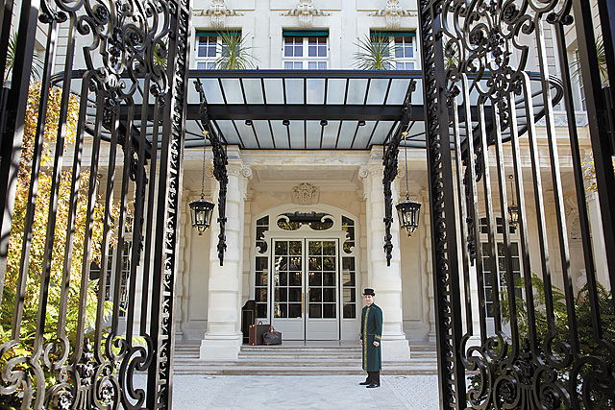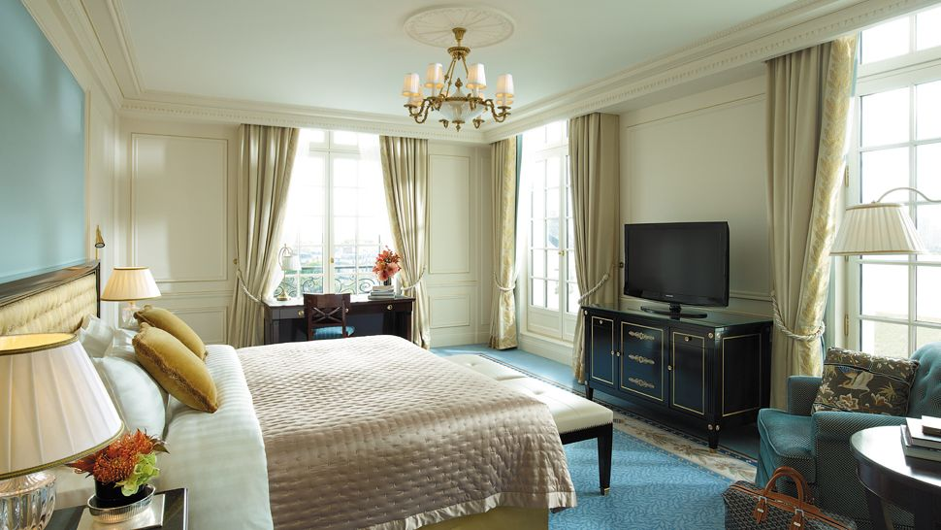

The Shangri-La combines a great view of the Eiffel Tower and an illustrious pedigree as the former town house of Prince Roland Bonaparte.

**Address** 10 avenue d'Iéna, 16th

**Telephone** 33-1 53 67 19 98

**Website** www.shangri-la.com

Le Meurice hotel

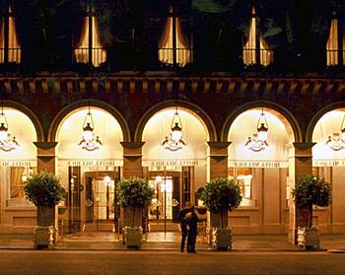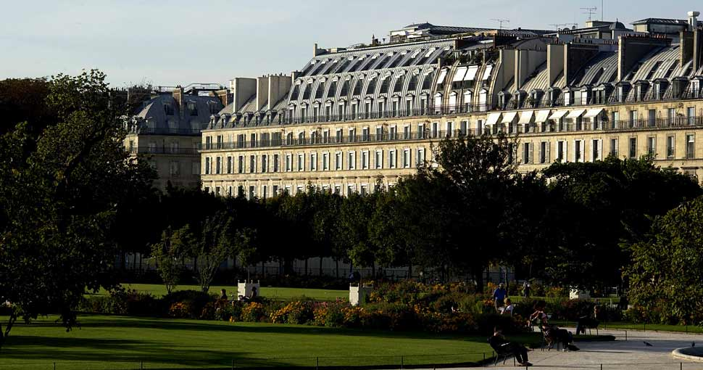

Le Meurice hotel is one of Paris's historic luxury hotels yet has cleverly kept up with the times with sumptuous rooms and fabulous food.

**Address** 228 rue de Rivoli, 75001 Paris

**Telephone** 0033 1 44 58 10 10

**Website** [www.lemeurice.com](http://www.lemeurice.com/)

Pershing Hall hotel

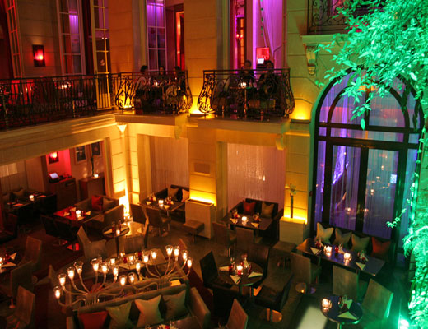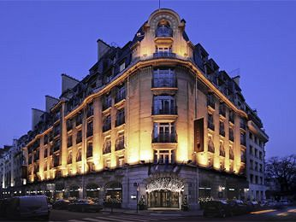

Pershing Hall in Paris is set in the mansion off the Champs-Elysées that served as General Pershing's HQ in World War I, a small luxury hotel with the aura of a grand one.

**Address** 49 rue Pierre-Charron, 75008 Paris

**Telephone** 0033 1 58 36 58 00

**Website** www.pershinghall.com

<http://www.telegraph.co.uk/travel/hotel/36309/Paris-hotels.html>

Restaurants

Le Meurice

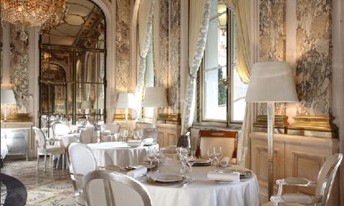

Anyone wanting a grand-slam experience of Gallic gastronomic grandeur won't do better than the glamorous dining room at the Hotel Meurice in the heart of the city. Though it was redecorated by Philippe Starck several years ago, it's good French bones survived intact – mosaic floor, crystal chandeliers, heavy damask curtains at the windows overlooking the Tuileries Gardens across the street – and the magnificent space is animated by old-school but friendly service that's as precise as a minuette. Chef Yannick Alléno bagged a third Michelin star in 2007, and his brilliantly inventive cooking is based on a deep knowledge of classical Escoffier vintage culinary technique. In addition to such recent creations as crispy green ravioli with a fricassee of snails and wild garlic, a starter, and spit-roasted red-wine marinated pigeon with red cabbage and apple juice, Alléno has become a dedicated locavore by occasionally featuring rare produce from the Ile de [France](http://www.guardian.co.uk/travel/france) – cabbage from Pontoise, honey from hives on the roof of [Paris](http://www.guardian.co.uk/travel/paris)'s Opéra Garnier – on his regularly evolving menu.

Information: 228 rue de Rivoli, 1st, + 33 1 44 58 10 10, [lemeurice.com](http://www.lemeurice.com/le-meurice-restaurant). Métro: Tuileries. Open for lunch and dinner from Mon-Fri. Average €200. Jackets compulsory at dinner

L'Astrance

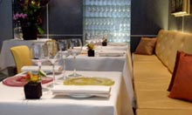

Despite the vertiginous prices of Paris haute cuisine, a meal at one of these nec plus ultra tables is an investment that just can't disappoint, and snagging a sought-after table at chef Pascal Barbot's three-star restaurant on a cobbled side street in the 16th arrondissement is well worth persistence. The smallest and most casual table at the top of the Parisian food chain, this high-ceilinged dining room with mirrored walls, widely spaced tables and friendly service offers a decidedly 21st-century take on French haute cuisine. Barbot, who trained with Alain Passard and once served as chef to the admiral of the French Pacific fleet, loves vegetables, fruit and fresh herbs, and his style is brilliantly witty and deeply imaginative, as seen in signature dishes such as his galette of finely sliced button mushrooms and verjus marinated foie gras dressed with hazelnut oil, or turbot with baby spinach and sea urchins, both of which are part of his regularly changing tasting menus.

Information: 4 rue Beethoven, 16th, +33 1 40 50 84 40. Métro: Passy. Open for lunch and dinner Tues–Fri. Average lunch €80, average dinner €200

Huitrerie Regis

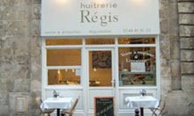

Tucked away in the heart of Saint Germain des Pres, this snug shop-front table with a white facade and interior is the best place in Paris for a fix of impeccably fresh oysters, which are delivered directly from France's Marennes-Oléron region on the Atlantic coast. Depending upon availability, prawns, clams and sea urchins can also be added to your plateau de fruits de mer, which will be served with bread and butter. A nice selection of mostly Loire valley white wines complements the bivalve-centric menu, and a convivial atmosphere is created by the jovial oyster shuckers and many local regulars.

Information: 3 rue de Montfaucon, 6th, +33 1 44 41 10 07, [huitrerieregis.com](http://huitrerieregis.com/). Métro: Mabillon or Saint Germain des Pres. Open Tues–Sun for lunch and dinner. Average €35. No reservations

<http://www.guardian.co.uk/travel/2011/may/06/top-10-paris-restaurants-dining>

Places you must visit

**Eiffel Tower**

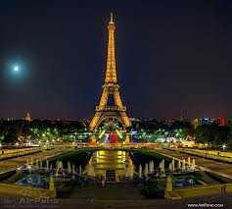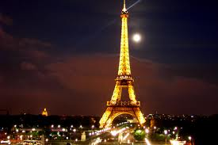

More than any other landmark, the [Eiffel Tower](http://goparis.about.com/od/parismonuments/p/Eiffel_Tower.htm) has come to represent an elegant and contemporary Paris. The iron tower, which was built for the 1889 World Exposition by Gustave Eiffel, was wildly unpopular with Parisians when it was unveiled, and was nearly torn down. It has since attracted over 220 million visitors, and it would be hard to imagine Paris now without it. The tower crowns the Paris night sky with its festive light, and glitters up a storm every hour. Cliché? Maybe. But essential.

**Notre Dame Cathedral**

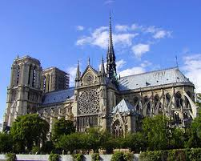

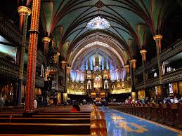

No first trip to Paris is complete without a visit to this marvel of gothic architecture. One of the most singular and beautiful cathedrals of Europe, [Notre Dame Cathedral's](http://goparis.about.com/od/sightsattractions/p/Notre_Dame.htm) dramatic towers, spire, stained glass and statuary are guaranteed to take your breath away. Witness firsthand the spot that was once the heartbeat of medieval Paris, and that took over 100 years of hard labor to complete. Climbing the North tower to see Paris from the hunchback Quasimodo's vantage is essential, too. You'll soon understand why Notre Dame is one of Paris' top attractions.

**The Louvre**

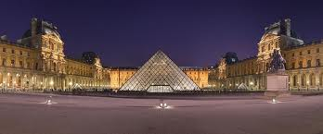

To learn [the Louvre](http://goparis.about.com/od/parismuseums/a/Louvre_Museum.htm) in and out, you might need a lifetime. Still, one has to start somewhere. The site of the world's largest and most diverse collection of pre-20th century painting, sculpture, and decorative objects, The Louvre is definitely one of Paris' most coveted attractions. Not forgetting the *Mona Lisa* and the *Venus de Milo*, bask in the works of Vermeer, Caravaggio, Rembrandt, and countless others. The palace itself is testament to a rich history spanning from the medieval period to the present.

<http://goparis.about.com/od/sightsattractions/tp/ParisTopTen.htm>

More information

http://en.wikipedia.org/wiki/Paris